**1. Вывести все директории в виде:**

**ID, Название, Путь до корня**

WITH RECURSIVE directory_tree AS (

SELECT

id,

name,

parent_id,

name::varchar(2000) AS path_to_root

FROM

public.file_system

WHERE

type = 'DIR' AND parent_id IS NULL

UNION ALL

SELECT

fs.id,

fs.name,

fs.parent_id,

CONCAT(dt.path_to_root, '/', fs.name)::varchar(2000) AS path_to_root

FROM

public.file_system AS fs

INNER JOIN

directory_tree AS dt

ON

fs.parent_id = dt.id

WHERE

fs.type = 'DIR'

)

SELECT

id,

name,

path_to_root

FROM

directory_tree

ORDER BY

path_to_root;

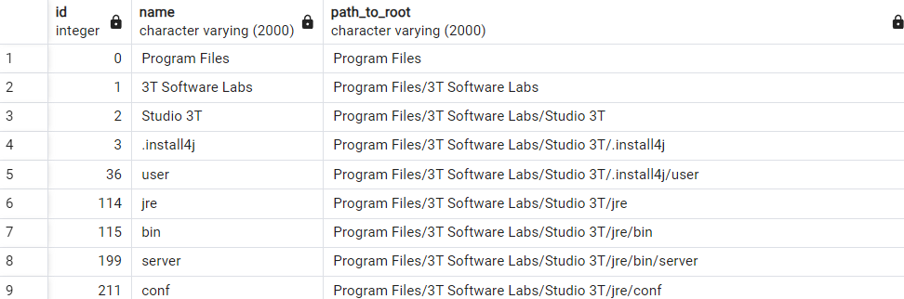

**3. Для каждой директории посчитать объем занимаемого места на диске (с учетом всех вложенных папок)**

**ID, Название, Путь до корня, total_size**

WITH RECURSIVE directory_tree AS (

SELECT

id,

name,

parent_id,

name::varchar(2000) AS path_to_root,

file_size,

CASE

WHEN type = 'DIR' THEN id

ELSE NULL

END AS directory_id

FROM

public.file_system

WHERE

parent_id IS NULL

UNION ALL

SELECT

fs.id,

fs.name,

fs.parent_id,

CONCAT(dt.path_to_root, '/', fs.name)::varchar(2000) AS path_to_root,

fs.file_size,

CASE

WHEN fs.type = 'DIR' THEN fs.id

ELSE dt.directory_id

END AS directory_id

FROM

public.file_system AS fs

INNER JOIN

directory_tree AS dt

ON

fs.parent_id = dt.id

)

SELECT

directory_id AS id,

MAX(name) AS name,

MAX(path_to_root) AS path_to_root,

SUM(file_size) AS total_size

FROM

directory_tree

WHERE

directory_id IS NOT NULL

GROUP BY

directory_id

ORDER BY

path_to_root;

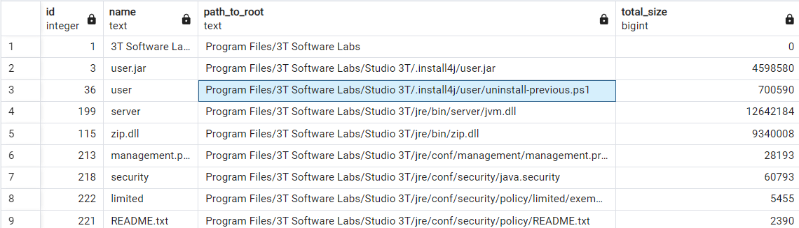

**4. Добавить в запрос: сколько процентов директория занимает места относительно всех среди своих соседей (siblings)**

**ID, Название, Путь до корня, total_size, ratio**

WITH RECURSIVE directory_tree AS (

SELECT

id,

name,

parent_id,

name::varchar(2000) AS path_to_root,

file_size,

CASE

WHEN type = 'DIR' THEN id

ELSE NULL

END AS directory_id

FROM

public.file_system

WHERE

parent_id IS NULL

UNION ALL

SELECT

fs.id,

fs.name,

fs.parent_id,

CONCAT(dt.path_to_root, '/', fs.name)::varchar(2000) AS path_to_root,

fs.file_size,

CASE

WHEN fs.type = 'DIR' THEN fs.id

ELSE dt.directory_id

END AS directory_id

FROM

public.file_system AS fs

INNER JOIN

directory_tree AS dt

ON

fs.parent_id = dt.id

)

, directory_sizes AS (

SELECT

directory_id AS id,

MAX(name) AS name,

MAX(path_to_root) AS path_to_root,

parent_id,

SUM(file_size) AS total_size

FROM

directory_tree

WHERE

directory_id IS NOT NULL

GROUP BY

directory_id, parent_id

)

SELECT

ds.id,

ds.name,

ds.path_to_root,

ds.total_size,

ROUND((ds.total_size * 100.0) / NULLIF(SUM(ds.total_size) OVER (PARTITION BY ds.parent_id), 0), 2) AS ratio

FROM

directory_sizes AS ds

ORDER BY

ds.path_to_root;

